Explain to me the Pythagorean theorem, incorporating (and using the appropriate signaling words to refer to) the equation and diagram below. Give the diagram an appropriate numbering and caption, to which you also refer in your write-up.

(1)

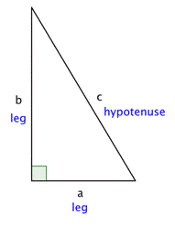

Figure 1 Pythagorean Theorem